**PROJECT DOCUMENT REPORT**

**ON**

**SOCIAL MEDIA APP**

**(MERN)**

**PRESENTED BY - MOHAMMAD FARAZ**

|  |  |
| --- | --- |
| Team ID | **SWUID20250206966** |

**ALL PROJECT CODE ,PROJECT DOC, FILES , DATASETS, CREDENTIALS, COURSE PATH INFORMATION LINKS -**

* **PROJECT DOCUMENT LINK (MAIN) WITH ALL PHOTOS** -<https://docs.google.com/document/d/1XIOUE7Fwr40tHpkNIkRu9E16hSJz8anl/edit?usp=sharing&ouid=110459874762096467411&rtpof=true&sd=true>
* **Project Demo Video link** - <https://drive.google.com/file/d/1pkpYH0q6QrKsAF9KzbRZoYuiI__GGzQs/view?usp=sharing>
* **GitHub link** –<https://github.com/FARAAZ-DEV/Social-Media-App-MERN-.git>
* **MongoDB NODE.JS DEVELOPER PATH(SMARTBRIDGE) :** <https://ti-user-certificates.s3.amazonaws.com/ae62dcd7-abdc-4e90-a570-83eccba49043/8380c446-a1a9-4174-bc26-932190d7afde-mohd-faraz-0b6e1889-c076-4f48-a721-c1d04f340d5d-certificate.pdf>

**PROJECT LIVE URL** : <https://social-media-app-mern-01.netlify.app/>

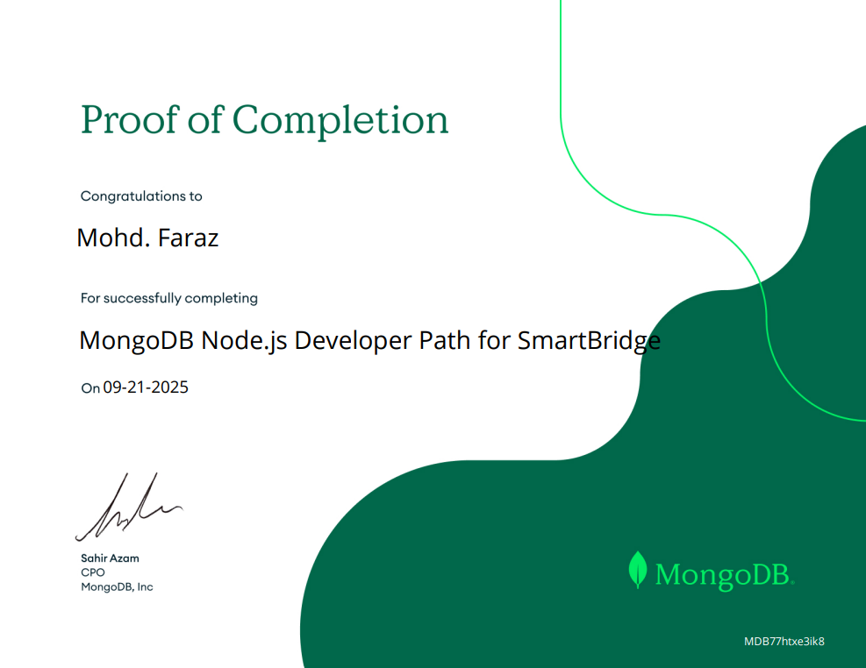

**PHASE - WISE DOCUMENTATION OF SOCIAL MEDIA APP (MERN)**

**Ideation Phase**

**Brainstorm & Idea Prioritization Template**

|  |  |
| --- | --- |
| Date | 11 October 2025 |
| Team ID | **SWUID20250206966** |
| Project Name | Social Media App (MERN) |
| Maximum Marks | 4 Marks |

**Brainstorm & Idea Prioritization Template:**Brainstorming provides a free and open environment that encourages everyone within a team to participate in the creative thinking process that leads to problem solving. Prioritizing volume over value, out-of-the-box ideas are welcome and built upon, and all participants are encouraged to collaborate, helping each other develop a rich amount of creative solutions.Use this template in your own brainstorming sessions so your team can unleash their imagination and start shaping concepts even if you're not sitting in the same room.Reference: <https://www.mural.co/templates/brainstorm-and-idea-prioritization>

**Step-1: Team Gathering, Collaboration and Select the Problem Statement**

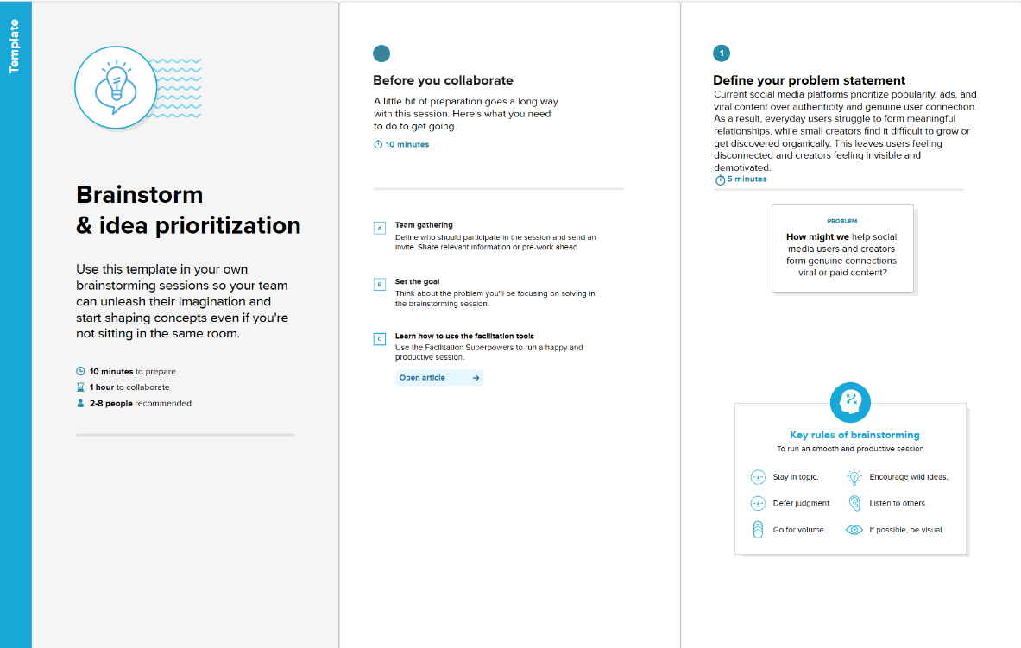

**Step-2: Brainstorm, Idea Listing and Grouping**

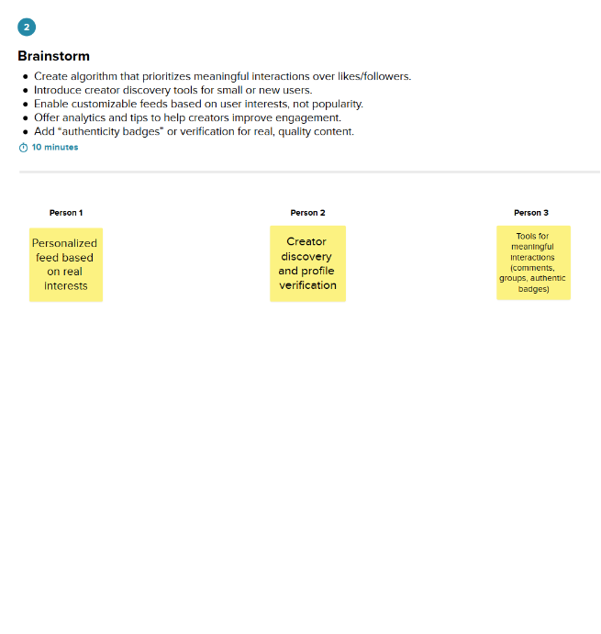

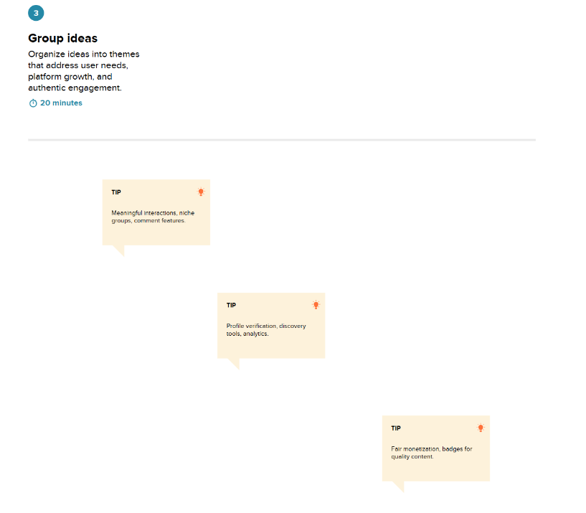

**Step-3: Idea Prioritization**

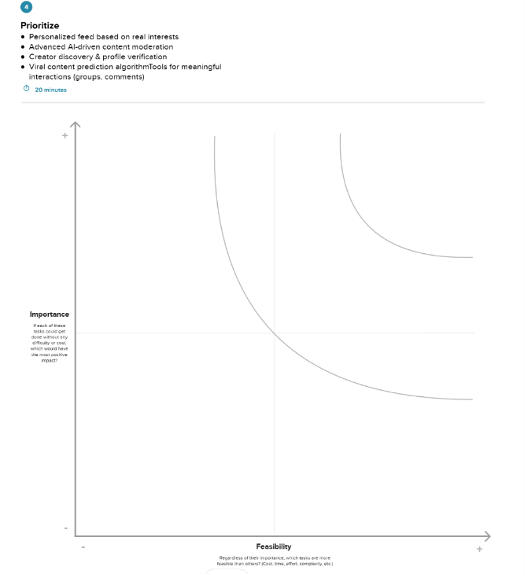

**Ideation Phase**

**Empathize & Discover**

|  |  |
| --- | --- |
| Date | 11 October 2025 |
| Team ID | **SWUID20250206966** |
| Project Name | Social Media App (MERN) |
| Maximum Marks | 4 Marks |

**Empathy Map Canvas:**

Understand the needs, frustrations, and behaviours of Social Media App users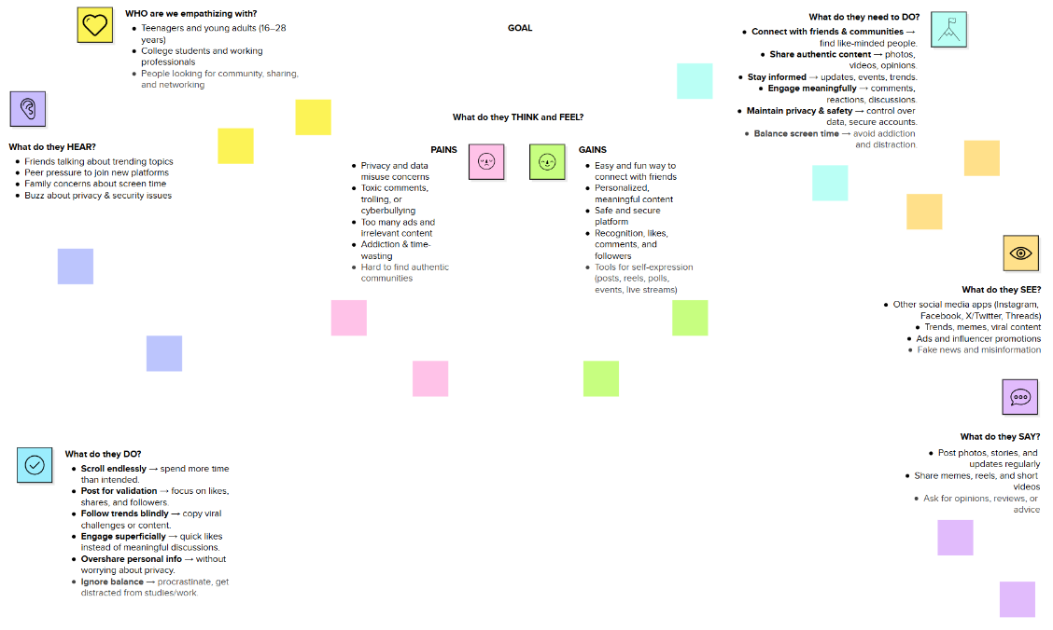seeking consistent work through a platform like Social Media App (MERN).

Reference: <https://www.mural.co/templates/empathy-map-canvas>

**Ideation Phase**

**Define the Problem Statements**

|  |  |
| --- | --- |
| Date | 11 October 2025 |
| Team ID | **SWUID20250206966** |
| Project Name | Social Media App (MERN) |
| Maximum Marks | 2 Marks |

**Customer Problem Statement Template:**

To define the core problems freelancers face while searching for jobs online, and use those insights to guide the development of Freelance Finder.

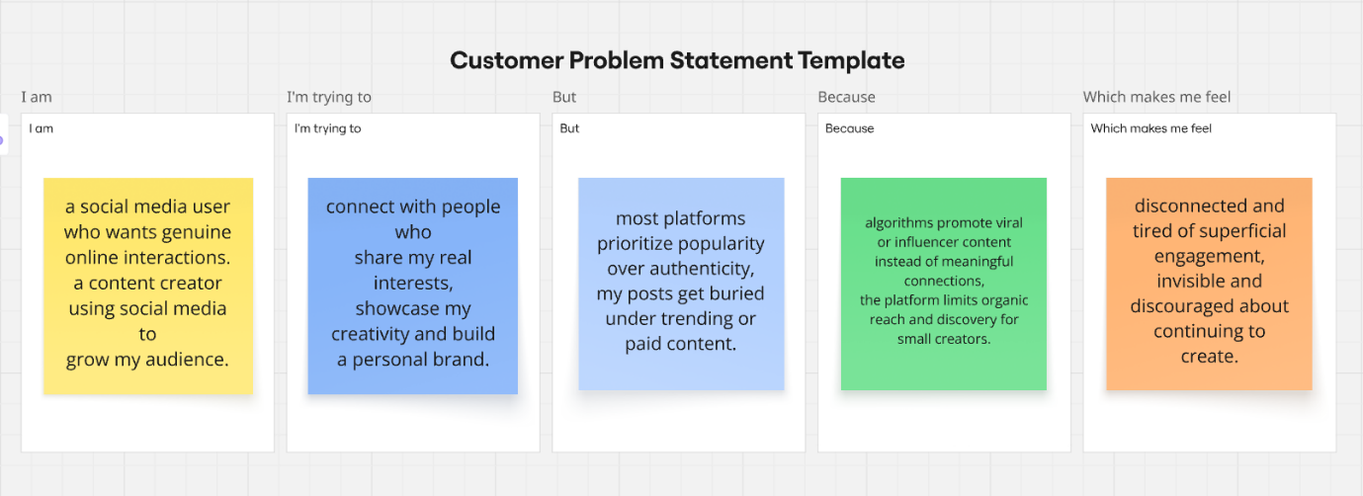

Reference: <https://miro.com/templates/customer-problem-statement/>

|  |  |  |  |  |  |
| --- | --- | --- | --- | --- | --- |
| **Problem Statement (PS)** | **I am (Customer)** | **I’m trying to** | **But** | **Because** | **Which makes me feel** |
| **PS-1** | a social media user. | connect with people who share my real interests. | most platforms prioritize popularity over authenticity. | algorithms promote viral or influencer content instead of meaningful connections. | disconnected and tired of superficial engagement. |
| **PS-2** | a content creator. | showcase my creativity and build a personal brand. | my posts get buried under trending or paid content. | the platform limits organic reach and discovery for small creators. | invisible and discouraged about continuing to create. |

**Project Design Phase-II**

**Data Flow Diagram & User Stories**

|  |  |
| --- | --- |
| Date | 11-10-2025 |
| Team ID | **SWUID20250206966** |
| Project Name | Social Media App (MERN) |
| Maximum Marks | 4 Marks |

**Data Flow Diagrams:**

A **Data Flow Diagram (DFD)** for the Social Media App (MERN) visually represents how users interact with the system to perform actions like posting, liking, and following, and how these data elements flow between frontend, backend, and MongoDB storage.

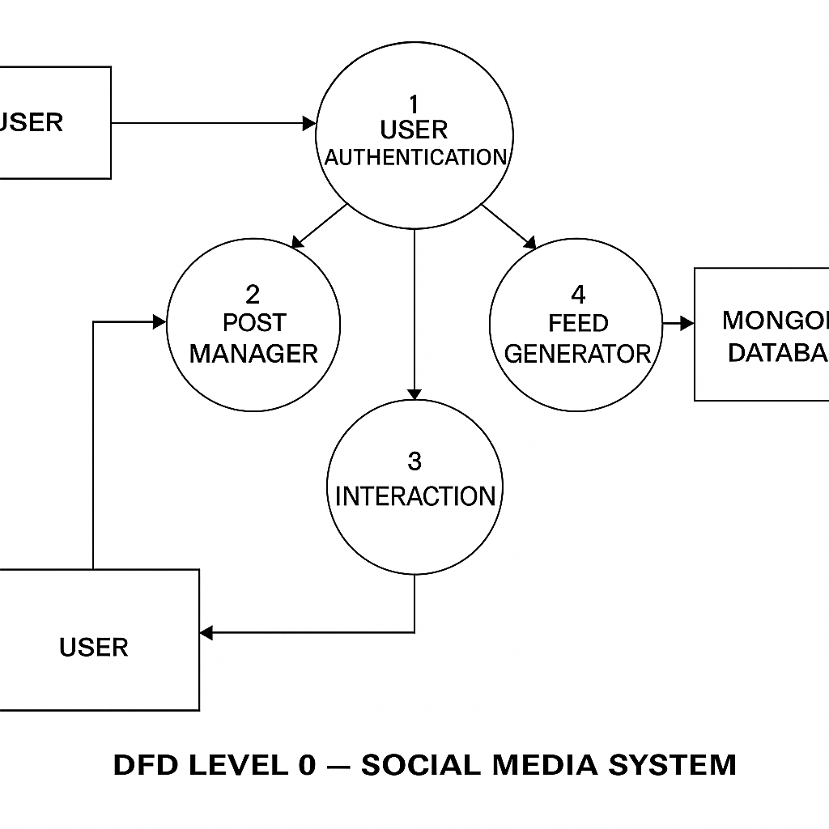

**User Stories**

**User Story Table –** Social Media App (MERN)

|  |  |  |  |  |  |
| --- | --- | --- | --- | --- | --- |
| **User Type** | **Functional Requirement (Epic)** | **User Story / Task** | **Acceptance Criteria** | **Priority** | **Release** |
| User | **User Registration & Login** | As a user, I can create an account and log in securely. | Successful login redirects to homepage with personalized feed. | High | Sprint-1 |
| User | **Profile Management** | As a user, I can update my profile details (bio, profile picture, etc.). | Updated details are reflected instantly on profile page. | High | Sprint-1 |
| User | **Post Creation** | As a user, I can create and share posts (text, images, or videos). | New post appears immediately on my profile and followers’ feed. | High | Sprint-2 |
| User | **Feed Viewing** | As a user, I can view posts from people I follow in my feed. | Feed displays recent posts in correct chronological order. | High | Sprint-2 |
| User | **Like & Comment** | As a user, I can like or comment on any post. | Likes and comments update instantly without page reload. | Medium | Sprint-2 |
| User | **Follow / Unfollow** | As a user, I can follow or unfollow other users. | Feed updates automatically based on follow list. | Medium | Sprint-2 |
| User | **Notifications** | As a user, I get notified when someone likes, comments, or follows me. | Notifications appear in the notification section in real-time. | Medium | Sprint-3 |
| User | **Chat / Messaging** | As a user, I can chat with my friends or followers in real-time. | Messages are sent and received instantly using WebSocket or Socket.io. | High | Sprint-3 |
| Admin | **User Management** | As an admin, I can view, block, or delete any user account. | Blocked users cannot log in; deleted accounts are removed from database. | High | Sprint-3 |
| Admin | **Content Moderation** | As an admin, I can delete inappropriate posts or comments. | Deleted content is removed from all users’ feeds. | High | Sprint-3 |

**Project Design Phase-II**

**Solution Requirements (Functional & Non-functional)**

|  |  |
| --- | --- |
| Date | 11-10-2025 |
| Team ID | **SWUID20250206966** |
| Project Name | Social Media App (MERN) |
| Maximum Marks | 4 Marks |

**Functional Requirements:**

Following are the functional requirements of the proposed solution.

**Functional Requirements – Social Media App**

|  |  |  |
| --- | --- | --- |
| **FR No.** | **Functional Requirement (Epic)** | **Sub Requirement (Story / Sub-Task)** |
| **FR-1** | **User Authentication** | User registration, login, and password reset functionality. OAuth login using Google or GitHub. |
| **FR-2** | **Post Management** | Users can create, edit, and delete posts (text, image, or video). Posts are visible on profile and followers’ feed. |
| **FR-3** | **Feed & Interaction** | Users can view posts from people they follow. Users can like, comment, and share posts in real-time. |
| **FR-4** | **Follow System** | Users can follow or unfollow others to customize their feed. |
| **FR-5** | **Messaging** | Real-time private chat between users using Socket.io. |
| **FR-6** | **Notifications** | Users receive alerts for likes, comments, new followers, and messages. |
| **FR-7** | **Admin Panel** | Admin can view, block, or delete users and remove inappropriate content. |

**Non-Functional Requirements:**

Following are the non-functional requirements of the proposed solution.

|  |  |  |
| --- | --- | --- |
| **NFR No.** | **Non-Functional Requirement** | **Description** |
| NFR-1 | **Usability** | The app should offer a clean, intuitive, and responsive UI suitable for users of all ages and skill levels, with easy navigation and content discovery. |
| NFR-2 | **Security** | All user data, messages, media, and authentication information must be encrypted. Implement role-based access control, secure token-based authentication, and protection against common threats (XSS, CSRF, SQL injection). |
| NFR-3 | **Reliability** | Ensure posting, messaging, media uploads, notifications, and feeds work reliably under all conditions without loss of data or messages. |
| NFR-4 | **Performance** | Pages, feeds, and media should load within 2 seconds. Real-time features like chat, notifications, and live updates should be near-instant. |
| NFR-5 | **Availability** | The platform should maintain 99.9% uptime and provide continuous service across all regions. |
| NFR-6 | **Scalability** | The system should handle high concurrency, viral content spikes, and rapid feature scaling, preferably using microservices and CDN-based media delivery. |
| NFR-7 | **Maintainability** | Codebase should be modular, documented, and easy to maintain or extend with new features. |
| NFR-8 | **Media Handling** | The app should support fast upload/download of images, videos, and other media, with adaptive streaming and compression to optimize performance. |
| NFR-9 | **Accessibility** | Ensure the app is accessible for users with disabilities (screen readers, color contrast, keyboard navigation). |

**Project Design Phase-II**

**Technology Stack (Architecture & Stack)**

|  |  |
| --- | --- |
| Date | 11-10-2025 |
| Team ID | **SWUID20250206966** |
| Project Name | Social Media App (MERN) |
| Maximum Marks | 4 Marks |

**Technical Architecture:**

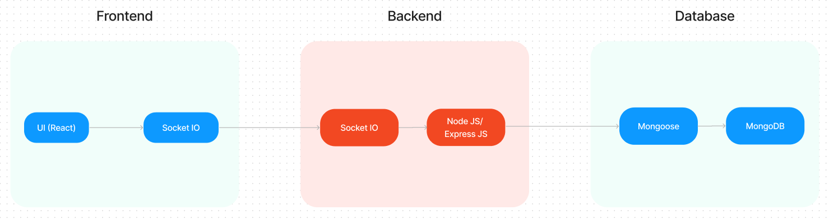

**Table-1 : Components & Technologies:**

|  |  |  |  |
| --- | --- | --- | --- |
| **S.No** | **Component** | **Description** | **Technology** |
| 1 | **User Interface** | Web-based interface for users to sign up, log in, post, like, comment, and view feeds | HTML, CSS, JavaScript, React.js |
| 2 | **Application Logic-1** | Handles user authentication, post creation, feed generation, and interactions (likes, comments, follows) | Node.js, Express.js |
| 3 | **Application Logic-2** | Admin panel for user management, content moderation, and notifications | React.js, Node.js |
| 4 | **Database** | Stores user profiles, posts, comments, likes, followers, and messages | MongoDB |

**Table-2: Application Characteristics:**

|  |  |  |  |
| --- | --- | --- | --- |
| **S.No** | **Characteristics** | **Description** | **Technology** |
| 1 | **Open-Source Frameworks** | Uses modern open-source frontend and backend frameworks for fast development and responsive UI | React.js, Node.js, Bootstrap, Tailwind CSS |
| 2 | **Scalable Architecture** | Built on a 3-tier MERN architecture following the MVC pattern with RESTful APIs for smooth data flow | MVC |

**References:**

**[React.js Documentation](https://react.dev/)**

**[Node.js Best Practice](https://nodejs.org/en/learn/getting-started/introduction-to-nodejs)**

**[JSON Web Server Reference](https://www.npmjs.com/package/json-server)**

**<https://medium.com/the-internal-startup/how-to-draw-useful-technical-architecture-diagrams-2d20c9fda90d>**

**Project Planning Phase**

**Project Planning Template (Product Backlog, Sprint Planning, Stories, Story points)**

|  |  |
| --- | --- |
| Date | 11-10-2025 |
| Team ID | **SWUID20250206966** |
| Project Name | Social Media App (MERN) |
| Maximum Marks | 5 Marks |

**Product Backlog, Sprint Schedule, and Estimation (4 Marks)**

**Product Backlog & Sprint Schedule**

|  |  |  |  |  |  |  |
| --- | --- | --- | --- | --- | --- | --- |
| **Sprint** | **Functional Requirement (Epic)** | **User Story Number** | **User Story / Task** | **Story Points** | **Priority** | **Team Members** |
| Sprint-1 | User Authentication | USN-1 | As a user, I can sign up and log in securely. | 3 | High |  |
|  |  | USN-2 | As a user, I can reset my password. | 2 | Medium |  |
|  |  | USN-3 | As a user, I can change my password. | 2 | Medium |  |
| Sprint-2 | Posts & Feeds | USN-4 | As a user, I can create text, image, or video posts. | 3 | High |  |
|  |  | USN-5 | As a user, I can view a feed of posts from my connections. | 3 | High |  |
|  |  | USN-6 | As a user, I can like or react to posts. | 2 | High |  |
| Sprint-3 | Interaction & Comments | USN-7 | As a user, I can comment on posts. | 2 | Medium |  |
|  |  | USN-8 | As a user, I can reply to comments. | 2 | Medium |  |
|  |  | USN-9 | As a user, I can share posts with others. | 2 | Medium |  |
| Sprint-4 | Messaging & Notifications | USN-10 | As a user, I can send and receive private messages. | 3 | High |  |
|  |  | USN-11 | As a user, I receive notifications for likes, comments, and messages. | 3 | High |  |
| Sprint-5 | Profile & Connections | USN-12 | As a user, I can edit my profile (name, bio, profile pic). | 2 | Medium |  |
|  |  | USN-13 | As a user, I can follow or connect with other users. | 3 | High |  |
|  |  | USN-14 | As a user, I can view other users’ profiles and posts. | 2 | Medium |  |

**Project Tracker, Velocity & Burndown Chart**

|  |  |  |  |  |  |  |
| --- | --- | --- | --- | --- | --- | --- |
| **Sprint** | **Total Story Points** | **Duration** | **Sprint Start Date** | **Sprint End Date (Planned)** | **Story Points Completed (as on Planned End Date)** | **Sprint Release Date (Actual)** |
| Sprint-1 | 7 | 6 Days | 1 May 2025 | 6 May 2025 | 7 | 6 May 2025 |
| Sprint-2 | 8 | 6 Days | 7 May 2025 | 12 May 2025 | 8 | 12 May 2025 |
| Sprint-3 | 6 | 6 Days | 13 May 2025 | 18 May 2025 | 6 | 18 May 2025 |
| Sprint-4 | 6 | 6 Days | 19 May 2025 | 24 May 2025 | 6 | 24 May 2025 |
| Sprint-5 | 7 | 6 Days | 25 May 2025 | 30 May 2025 | 7 | 30 May 2025 |

**Project Design Phase**

**Problem – Solution Fit Template**

|  |  |
| --- | --- |
| Date | 11-10-2025 |
| Team ID | **SWUID20250206966** |
| Project Name | Social Media App (MERN) |
| Maximum Marks | 2 Marks |

**Problem – Solution Fit Overview:**

The Problem–Solution Fit ensures that the Social Media App addresses the real gaps users face in existing social platforms and aligns with the needs of modern users. This validation is critical before scaling the app.

**Purpose:**

* **Connect people meaningfully** by bridging gaps between friends, communities, and interest groups.
* **Offer an all-in-one platform** for sharing content, messaging, events, and live interactions without switching apps.
* **Ensure user safety and privacy** through secure data handling, content moderation, and customizable privacy settings.
* **Provide visibility for creators and new users** through smart content discovery and trending feeds.
* **Enhance engagement and experience** through real-time chat, reactions, comments, and user-friendly UI/UX.

**Problem Statement:**

Many social media users face challenges such as:

* Lack of meaningful engagement or authentic interactions
* Overexposure to irrelevant content, ads, or misinformation
* Privacy and security concerns while sharing personal content
* Difficulty discovering relevant communities, trends, or friends
* Absence of centralized tools for posting, messaging, and interacting

**Solution:**

The Social Media App, a modern full-stack platform, offers:

* **All-in-one content sharing**: Post text, images, videos, stories, and polls seamlessly.
* **Secure interactions**: Privacy settings, content moderation, and reporting tools to ensure a safe environment.
* **Smart content discovery**: AI-driven feeds, trending posts, and community recommendations based on interests and behaviour.
* **Real-time communication**: Chat, notifications, reactions, and comments for instant engagement.
* **User profiles & personalization**: Customizable profiles with bio, posts, followers, and activity history.
* **Community & group management**: Create, join, and participate in interest-based groups and events.
* **Freemium model**: Free to use with premium features like post boosts, analytics, ad-free experience, and enhanced visibility for creators.

**Project Design Phase**

**Proposed Solution Template**

|  |  |
| --- | --- |
| Date | 11-10-2025 |
| Team ID | **SWUID20250206966** |
| Project Name | Social Media App (MERN) |
| Maximum Marks | 2 Marks |

**Proposed Solution for Social Media App**

|  |  |  |
| --- | --- | --- |
| **S. No.** | **Parameter** | **Description** |
| 1 | **Problem Statement (Problem to be solved)** | Many social media users face difficulty in connecting meaningfully, discovering relevant content, ensuring privacy, and engaging safely. Lack of personalized feeds, secure communication, and community management leads to low engagement and dissatisfaction. |
| 2 | **Idea / Solution Description** | The Social Media App is a full-stack web application (React frontend + Node.js backend) that allows users to post text, images, videos, stories, and polls; connect with friends and communities; and interact via real-time chat and notifications. Admin controls manage content moderation, privacy, and reporting. |
| 3 | **Novelty / Uniqueness** | - AI-powered personalized content feeds - Built-in real-time messaging and reactions - Privacy-first features (customizable settings, reporting) - Interest-based communities and events - Optional live streaming for creators |
| 4 | **Social Impact / Customer Satisfaction** | - Enables meaningful social connections globally - Helps creators gain visibility and engage followers - Promotes safe and respectful online interactions - Encourages community building and knowledge sharing |
| 5 | **Business Model (Revenue Model)** | - Freemium access for general users - Premium membership for ad-free experience, analytics, and post boosts - Sponsored content & promotions for brands - Optional enterprise/community management plans |
| 6 | **Scalability of the Solution** | - Expandable to global markets with multi-language support - Mobile-first design with future React Native apps - Modular architecture to integrate AI recommendations, live streaming, and advanced analytics |

**Project Design Phase**

**Solution Architecture**

|  |  |
| --- | --- |
| Date | 26 -052025 |
| Team ID | **SWUID20250206966** |
| Project Name | Social Media App (MERN) |
| Maximum Marks | 4 Marks |

**Solution Architecture:**

The solution architecture ensures a **robust, user-friendly, and scalable social media platform** that connects users, communities, and content creators. The architecture focuses on **responsive design, secure interactions, personalized content, and real-time communication** to ensure high engagement and user satisfaction.

**Key Features of the Architecture:**

* **Seamless content sharing** – users can post text, images, videos, stories, and polls effortlessly.
* **End-to-end interaction management** – supports likes, comments, shares, and community participation.
* **Scalable user authentication & authorization** – secure login/signup with social OAuth integration.
* **Privacy-first design & secure data handling** – content moderation, reporting, and customizable privacy settings.
* **Reliable real-time chat & notifications** – instant messaging, reactions, and alerts for interactions.
* **AI-driven content discovery** – personalized feeds, trending posts, and interest-based recommendations.
* **Modular & scalable backend** – supports future features like live streaming, events, and analytics dashboards.

**Example - Solution Architecture Diagram:**

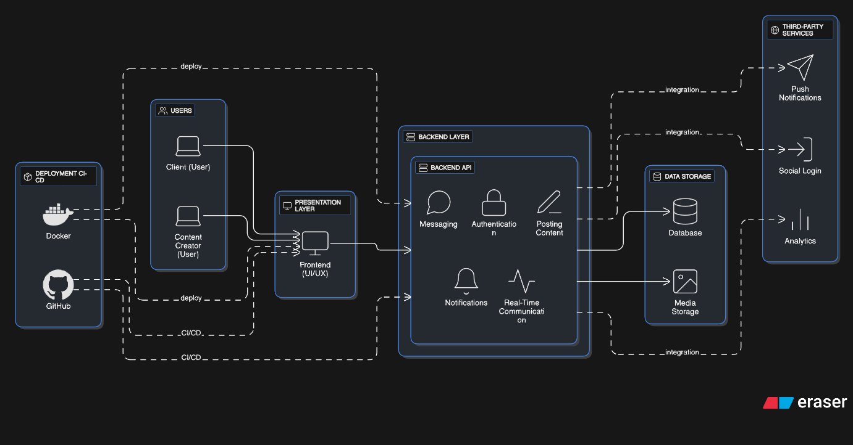

**User Acceptance Testing (UAT) Template**

|  |  |
| --- | --- |
|  | |
| Date | 11-10-2025 |
| Team ID | **SWUID20250206966** |
| Project Name | Social Media App (MERN) |
| Maximum Marks |  |

**Project Name:** Social Media App (MERN)  
**Description:** A web-based social media platform that allows users to create profiles, connect with friends, share posts, message each other, and interact through likes, comments, and notifications.  
**Project Version:** v1.0.0  
**Testing Period:** 2025-05-26 to 2025-06-02

**Testing Scope:**

* User registration and login
* User profile creation and customization
* Posting content (text, images, videos)
* Like, comment, and share functionalities
* Messaging and notifications system
* Search and friend request functionalities
* Privacy settings and account security
* Reporting inappropriate content and users
* Analytics on user interactions (optional)

**Requirements to be Tested:**

* As a user, I want to register and login securely.
* As a user, I want to create and customize my profile.
* As a user, I want to post updates, images, or videos.
* As a user, I want to like, comment, and share posts.
* As a user, I want to send messages and receive notifications.
* As a user, I want to search for other users and send friend requests.
* As an admin, I want to manage reported content and users.
* As a user, I want privacy controls to protect my account and content.

**Testing Environment:**

**Testing Environment**

* **URL**: <https://social-media-app-mern-01.netlify.app/>
* **Credentials**:  
  + **User**: user@example.com / password123
  + **Admin**: admin@example.com / adminpass123

**PROJECT CREDENTIALS**

* **Project Demo Video link** - <https://drive.google.com/file/d/1pkpYH0q6QrKsAF9KzbRZoYuiI__GGzQs/view?usp=sharing>
* **GitHub link** –<https://github.com/FARAAZ-DEV/Social-Media-App-MERN-.git>
* **MongoDB NODE.JS DEVELOPER PATH(SMARTBRIDGE) :** <https://ti-user-certificates.s3.amazonaws.com/ae62dcd7-abdc-4e90-a570-83eccba49043/8380c446-a1a9-4174-bc26-932190d7afde-mohd-faraz-0b6e1889-c076-4f48-a721-c1d04f340d5d-certificate.pdf>

**Test Cases:**

|  |  |  |  |  |  |
| --- | --- | --- | --- | --- | --- |
| **Test Case ID** | **Test Scenario** | **Test Steps** | **Expected Result** | **Actual Result** | **Pass/Fail** |
| TC-001 | User Registration | 1. Visit site  2. Click "Sign Up"  3. Fill and submit registration form | Account is created and user is redirected to dashboard/homepage | [Actual Result] | [Pass/Fail] |
| TC-002 | User Login | 1. Visit site  2. Click "Login"  3. Enter valid credentials and submit | User is logged in and redirected to dashboard/homepage | [Actual Result] | [Pass/Fail] |
| TC-003 | Profile Creation & Update | 1. Login  2. Go to "Profile"  3. Fill profile details (name, bio, photo)  4. Save changes | Profile is created/updated successfully and visible to others | [Actual Result] | [Pass/Fail] |
| TC-004 | Post Content | 1. Login  2. Go to "Create Post"  3. Enter text/image/video  4. Submit post | Post appears on user’s timeline and newsfeed | [Actual Result] | [Pass/Fail] |
| TC-005 | Like/Comment/Share | 1. Login  2. Go to any post  3. Like, comment, and share post | Like count updates, comment appears, post is shared | [Actual Result] | [Pass/Fail] |
| TC-006 | Friend Request / Follow | 1. Login  2. Search for a user 3. Send friend request/follow | Friend request sent; status changes to pending or followed | [Actual Result] | [Pass/Fail] |
| TC-007 | Messaging | 1. Login  2. Open messaging 3. Send message to friend | Message is delivered and visible to recipient | [Actual Result] | [Pass/Fail] |
| TC-008 | Notifications | 1. Perform actions like like/comment/friend request  2. Check notifications | Relevant notifications appear in real-time | [Actual Result] | [Pass/Fail] |
| TC-009 | Search Users/Posts | 1. Login  2. Use search bar to search users or posts | Search results display correctly | [Actual Result] | [Pass/Fail] |
| TC-010 | Privacy Settings | 1. Login  2. Go to "Settings" 3. Adjust privacy option. |  |  |  |

**Bug Tracking:**

|  |  |  |  |  |  |
| --- | --- | --- | --- | --- | --- |
| **Bug ID** | **Bug Description** | **Steps to Reproduce** | **Severity** | **Status** | **Additional Feedback** |
| BG-001 | Error on user registration | 1. Visit "Sign Up" page 2. Submit form with empty fields | High | Open | Form should show validation errors for required fields |
| BG-002 | Unable to login with valid credentials | 1. Go to "Login" 2. Enter valid email & password 3. Click "Login" | High | Open | Check authentication API and database connection |
| BG-003 | Profile picture not uploading | 1. Go to "Profile" 2. Try uploading image 3. Click "Save" | Medium | Open | File upload validation or server handling may be missing |
| BG-004 | Posts not appearing on timeline | 1. Create a post 2. Submit 3. Check timeline | High | Open | Ensure posts are saved to database and fetched correctly |
| BG-005 | Likes/Comments not updating | 1. Like or comment on a post 2. Refresh page | Medium | Open | Check real-time update or API response handling |
| BG-006 | Friend request not sent | 1. Search user 2. Click "Add Friend" | Medium | Open | Verify backend request handling for friend requests |
| BG-007 | Messages not delivered | 1. Open messaging 2. Send message | High | Open | Check WebSocket or API connection for real-time messaging |
| BG-008 | Notifications not showing | 1. Perform an action (like/comment/friend request) | Medium | Open | Ensure notification service triggers correctly |
| BG-009 | Privacy settings not applied | 1. Change privacy settings 2. Logout and login again | Medium | Open | Verify settings are correctly saved in the database |
| BG-010 | Logout fails | 1. Click "Logout" | High | Open | Session may not be cleared or token invalidation fails |

**Sign-off:**

Tester Name: .

Date: 11-10-2025

Signature: **MOHAMMAD FARAZ**

**Notes:**

* Ensure that all test cases cover both positive and negative scenarios.
* Encourage testers to provide detailed feedback, including any suggestions for improvement.
* Bug tracking should include details such as severity, status, and steps to reproduce.
* Obtain sign-off from both the project manager and product owner before proceeding with deployment.